MedAptus
  - Integration Package
athenahealth, Inc.
Version 17.1 Published: January 2017

Project Overview

Product Description
With this integration, patients and appointments are sent from athenaCollector to MedAptus, and charges are sent back to athenaCollector for billing. MedAptus uses our API to pull additional information on patients as well as the provider and department tables, and to create patients in your athenaNet tablespace when necessary.

Project Information
Please fill the following to the best of your ability. While not all contacts are required, you should be able to submit at least two contacts at the onset of a new interface project.
General Information
athenahealth Practice Context ID
athenahealth Interface Project Manager Name
athenahealth Interface Project Manager Contact Information
Event Number (provided by Interface Project Manager, for internal athenahealth tracking)

Contact | Role | Details
Project Business Contact | Responsible for overall success of the project | Name:
 |  | Phone:
 |  | Email:
Project Interface Contact | Interface expert, responsible for continuing interface support | Name:
 |  | Phone:
 |  | Email:
Project IT Contact | Networking and security expert, responsible for overall connectivity | Name:
 |  | Phone:
 |  | Email:
Vendor Contact #1 | Role: | Name:
 |  | Phone:
 |  | Email:
Vendor Contact #2 | Role: | Name:
 |  | Phone:
 |  | Email:

Interface Design

Technical Overview

Third Party System | MedAptus
Interface Type | Outbound Patients and Appointments and Inbound Charges (HL7) + API
Schematic | 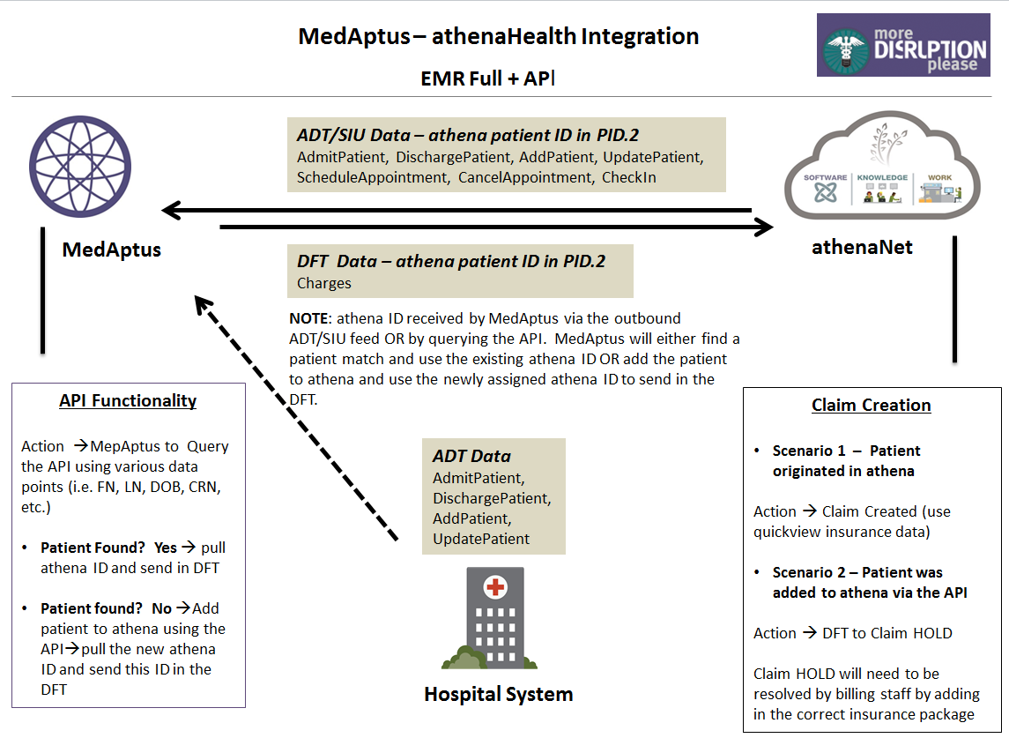
Format | HL7, API
Data Transfer Direction | Outbound from athenaNet to MedAptus for ADT/SIU  Inbound from MedAptus to athenaNet for DFT
Frequency of Data Transfer | Real Time
HL7 Message Type(s) | Outbound (from athenaNet): AddPatient (A28), UpdatePatient (A31), AdmitPatient (A01), DischargePatient (A03), ScheduleAppointment (S12), CheckIn (S14), CancelAppointment (S15), ReferringProviderAdd (M02), ReferringProviderUpdate (M02), ReferringProviderDelete (M02), ReferringProviderUndelete (M02)  Inbound (into athenaNet): DFT^P03
API Endpoints | POST /patients  GET /patients/enhancedbestmatch  GET /providers  GET /departments  GET /customfields
Connectivity | VPN, API
Options | N/A
Restrictions | Requires integration with athenaCollector

Additional Comments
Please use this section for any additional questions or comments related to this integration.

Scope Approval
I, , agree to the interface design as described here in this document.
Position:
Date:

Go-Live Authorization Form

Continuing Service and Support
Within two weeks after go-live your interface will be transitioned into our daily service and support structure.
As a standard practice, athenahealth continuously monitors all client connections and will notify the contacts specified if an error occurs. All jobs are monitored and automatically restarted if idle.
To contact athenahealth for help or support post go-live, the following resources are available:

¹ Integration Monitoring: IntegrationMonitoringRequests@athenahealth.com
Additionally, it is required to provide support contact information for the client and trading partner for use by athenahealth interface support. When possible, general support hotlines and email address are preferred.
Name | Company | Title | Office Phone | Mobile Phone | Email

Interface Go-Live Signoff
Reference is made to the Athenahealth services agreement (the “Agreement”) entered into by and between athenahealth, Inc. (“Athena”) and the client set forth on the signature page below (“Client”, “you” or “your”). In order to move your interface (or interface change requiring testing) (the “Interface”) into your athenaNet production environment, you must sign off on the functionality of the Interface by execution of this Go Live Authorization Form. Client agrees to fully cooperate with Athena and provide all assistance reasonably necessary for Athena to create, implement and maintain the Interfaces. Client acknowledges that Athena’s performance is contingent on Client’s timely and effective performance of its obligations and understands that the operability of the Interfaces depends on Client’s ability to maintain its own equipment and functionality. Client has obtained or will obtain all consents, licenses, and waivers and has fulfilled all legal obligations that are necessary to allow Athena to create, implement and maintain the Interfaces. It should be understood that additional changes to the scope of the Interface once loaded into athenaNet production will involve additional project work and potentially incur additional costs. In addition, Client acknowledges that moving the Interface to athenaNet production environment may require changes to athenaNet practice settings and in connection with this Go-Live Authorization Form authorizes all required changes in athenaNet.
Upon receipt of this signed form, Athena requires a minimum of 2 business days to move your Interface to go live.
The terms of this Go Live Authorization Form are hereby incorporated into the Agreement and shall become effective upon Client’s signature below. By signing below, Client acknowledges that it is satisfied with the functionality of the Interface set forth below and Client authorizes Athena to enable such Interface to be deployed to athenaNet production.

CLIENT:
By: _________________________________________
Print Name:
Position:
Date:

