Ingenious Med
  - Integration Package
athenahealth, Inc.
Version 17.12 Published: December 2017

Project Overview

Product Description
With this integration, patient and appointments are sent from athenaCollector to Ingenious Med, and charges are sent back to athenaCollector for billing. Ingenious Med uses the API to create the patient in athenaNet if they don’t already exist there.

Project Information
Please fill the following to the best of your ability. While not all contacts are required, you should be able to submit at least two contacts at the onset of a new interface project.
General Information
athenahealth Practice Context ID
athenahealth Interface Project Manager Name
athenahealth Interface Project Manager Contact Information
Event Number (provided by Interface Project Manager, for internal athenahealth tracking)

Contact | Role | Details
Project Business Contact | Responsible for overall success of the project | Name:
 |  | Phone:
 |  | Email:
Project Interface Contact | Interface expert, responsible for continuing interface support | Name:
 |  | Phone:
 |  | Email:
Project IT Contact | Networking and security expert, responsible for overall connectivity | Name:
 |  | Phone:
 |  | Email:
Vendor Contact #1 | Role: | Name:
 |  | Phone:
 |  | Email:
Vendor Contact #2 | Role: | Name:
 |  | Phone:
 |  | Email:

Interface Design

Technical Overview
Third Party System | Ingenious Med
Interface Type | Outbound Patients and Appointments and Inbound Charges (HL7) + API
Schematic | 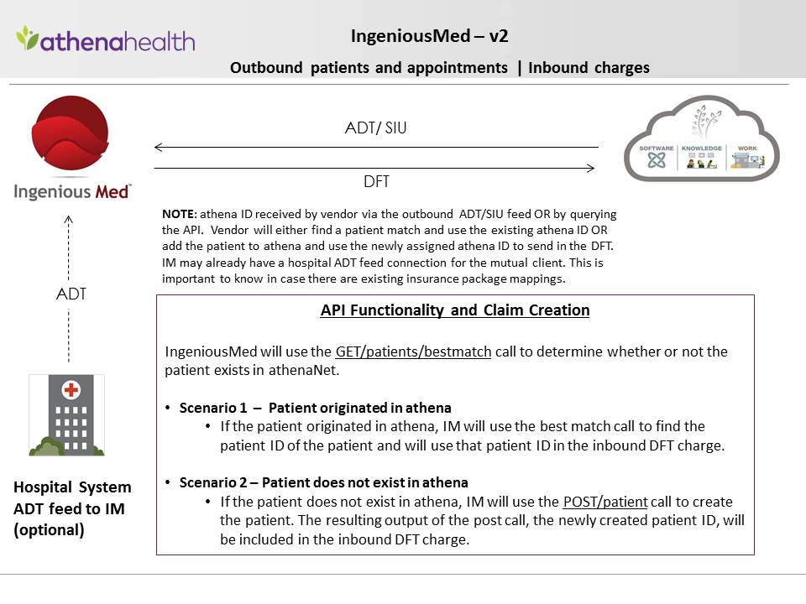
Format | HL7, API
Data Transfer Direction | Outbound from athenaNet to Ingenious Med for ADT/SIU  Inbound from Ingenious Med to athenaNet for DFT
Frequency of Data Transfer | Real time
HL7 Message Types | Outbound (from athena): AddPatient (HL7 A28), ScheduleAppointment (HL7 S12), CancelAppointment (HL7 S15), CheckIn (HL7 S14), UpdatePatient (HL7 A31), UpdatePatient (HL7 A08), DischargePatient (HL7 A03), AdmitPatient (HL7 A01)  Inbound (into athena): DFT (P03)
API Endpoints | GET /patients/enhancedbestmatch  POST /patients  GET /providers  GET /customfields  GET /departments
Details | DFT: Charge grouping enabled  DFT: When we receive a charge from IngeniousMed and the patient is not registered in that given provider group, we automatically CPI copy the patient into that provider group.  DFT: For a period of 10 days after the first DFT message processes, an automatic INTERFACEREVIEW hold is placed on all claims for review by the practice.
Connectivity | VPN, API
Restrictions | Requires integration with athenaCollector

Claim Creation:
Ingenious Med sends charge information inbound to athena on P03 messages for claims to be billed out of athenaCollector. The Ingenious Med v3 interface has the capability to process the insurance information on the charge messages to remove unnecessary claim holds and reduce client work in athenaNet. If there is no insurance information on the patient Quickview, the interface will use insurance information from Ingenious Med to create the claim. If there is insurance information on both the patient Quickview and the charge message from Ingenious Med, there are two separate interface offerings.
Ingenious Med version 3 will populate charge message insurance from Ingenious Med onto claims created in athena.
Ingenious Med version 3.5 will use athena Quickview insurance information on claims generated by Ingenious Med. Message information will override Quickview information only if the patient in athenaNet has a primary insurance listed as self-pay, or if the inbound message insurance contains a case policy (ex: Worker’s Compensation). Please note, self pay packages are only recognized if they have the package ID 0 or -100, our athenaNet wide values.
For both interface offerings, any insurance information sent inbound from Ingenious Med that is used on a claim will not be added to the patient Quickview. Instead, it will be added to the claim and added as a cancelled insurance onto the patient’s Quickview. This is to ensure minimal interference with other client workflows and patient data entered by users in athenaNet.

What insurance data should be used on claims if there is existing athenaNet insurance information on the patient Quickview?
Version 3: ONLY USE ATHENA INSURANCE INFORMATION IF MESSAGE DOES NOT CONTAIN INSURANCE INFORMATION:
Insurance from Ingenious Med will populate the claim even if there is existing athena insurance information on the Quickview.
Version 3.5: USE ATHENA INSURANCE INFORMATION AND IGNORE MESSAGE INSURANCE
If there is existing athenaNet insurance information on the patient’s Quickview, claims should be created with athena information.
ONLY ONE SELECTION: Only one of the above insurance processing options may be selected, and this option will be coded for the entire tablespace as athena cannot selectively process by department, provider group, or other custom condition.

Scope Approval
I, , agree to the interface design as described here in this document.
Position:
Date:

Go-Live Authorization Form

Continuing Service and Support
Within two weeks after go-live your interface will be transitioned into our daily service and support structure.
As a standard practice, athenahealth continuously monitors all client connections and will notify the contacts specified if an error occurs. All jobs are monitored and automatically restarted if idle.
To contact athenahealth for help or support post go-live, the following resources are available:

¹ Integration Monitoring: IntegrationMonitoringRequests@athenahealth.com
²Interface Network Management: InterfaceNetworkManagement@athenahealth.com
Additionally, it is required to provide support contact information for the client and trading partner for use by athenahealth interface support. When possible, general support hotlines and email address are preferred.
Name | Company | Title | Office Phone | Mobile Phone | Email

Interface Go-Live Signoff
Reference is made to the Athenahealth services agreement (the “Agreement”) entered into by and between athenahealth, Inc. (“Athena”) and the client set forth on the signature page below (“Client”, “you” or “your”). In order to move your interface (or interface change requiring testing) (the “Interface”) into your athenaNet production environment, you must sign off on the functionality of the Interface by execution of this Go Live Authorization Form. Client agrees to fully cooperate with Athena and provide all assistance reasonably necessary for Athena to create, implement and maintain the Interfaces. Client acknowledges that Athena’s performance is contingent on Client’s timely and effective performance of its obligations and understands that the operability of the Interfaces depends on Client’s ability to maintain its own equipment and functionality. Client has obtained or will obtain all consents, licenses, and waivers and has fulfilled all legal obligations that are necessary to allow Athena to create, implement and maintain the Interfaces. It should be understood that additional changes to the scope of the Interface once loaded into athenaNet production will involve additional project work and potentially incur additional costs. In addition, Client acknowledges that moving the Interface to athenaNet production environment may require changes to athenaNet practice settings and in connection with this Go-Live Authorization Form authorizes all required changes in athenaNet.
Upon receipt of this signed form, Athena requires a minimum of 2 business days to move your Interface to go live.
The terms of this Go Live Authorization Form are hereby incorporated into the Agreement and shall become effective upon Client’s signature below. By signing below, Client acknowledges that it is satisfied with the functionality of the Interface set forth below and Client authorizes Athena to enable such Interface to be deployed to athenaNet production.

CLIENT:
By: _________________________________________
Print Name:
Position:
Date:

