File System Link
  - Integration Package
athenahealth, Inc.
Version 16.9 Published: September 2016

Project Overview

Product Description
The File System Link is a URL or UNC path that will take users from athenaNet to an external directory. This external directory must be hosted by the client or another 3rd party service provider. Athena will put the link in the ‘Medical Files’ section of the Quickview and on the Streamlined chart under Third Party Applications. On the Classic chart, the link is at the top of the FaceSheet.

Project Information
Please fill the following to the best of your ability. While not all contacts are required, you should be able to submit at least two contacts at the onset of a new interface project.
General Information
athenahealth Practice Context ID
athenahealth Interface Project Manager Name
athenahealth Interface Project Manager Contact Information
Event Number (provided by Interface Project Manager, for internal athenahealth tracking)

Contact | Role | Details
Project Business Contact | Responsible for overall success of the project | Name:
 |  | Phone:
 |  | Email:
Project IT Contact | Networking and security expert, responsible for overall connectivity | Name:
 |  | Phone:
 |  | Email:

Delivery Configuration

File Link Configuration
This offering simply enables a direct link from athenaNet to a remote, customer-operated file system. Athena supports several methods of accessing the remote system.

Link Type
Indicate the Method to be Used to Access the Remote File System (check one):
Windows Universal Naming Convention (UNC) path, e.g. \\servername\pathname
Standard URL, e.g. http://servername/pathname
FTP link, e.g. ftp://servername/pathname

Link Address
The File System Link offering is capable of accessing either a folder on the remote file system (“pathname” in the examples above), or a particular file, such as \\servername\pathname\insurancecard.jpg. The folder structure on the remote server has to be created and managed by the owner of the system. It could be set up to bring users to a general folder (not patient specific) from where they can navigate to a particular patient’s folder, or it can be setup so that the link brings users directly to the patient’s folder. If the latter configuration, the particular path or file that the link accesses on the remote file system must be identifiable by the patient. Therefore, the folder structure (path) must include either the athenaNet patient ID or another patient id that is stored in athenaNet.
Please provide the full link here:

Patient Identifier
If this link is patient specific, indicate the patient ID being used:
athenaNet patient ID
athenaNet Enterprise patient ID
External patient ID stored in athenaNet (please specify custom field name)

Link Display Name
Please provide the display name of the link shown in athenaNet

Link Filtering
Should athenaNet apply filtering so that the link only displays to users that are logged into a certain department or provider group, or so that it only displays for certain providers?
Indicate the Method to be Used to Access the Remote File System (check one):
Provider Group Filtering
Filter only for the following Provider Groups:
Department Filtering
Filter only for the following Departments:
Provider Filtering
Filter only for the following Providers:

External File System Requirements
As noted above, athenahealth is not responsible for the organization of the remote file system. This section includes recommendations on how the system could be setup. Technically, this organization might be implemented as follows:
- Your Windows system administrator creates a set of folders on a network share (e.g.\\servername); these folders will be the location of the stored files. By convention, all documents for patients from 1-999 could be stored in folder 0; all documents for patients from 1000 to 1999 could be stored in folder 1, etc.
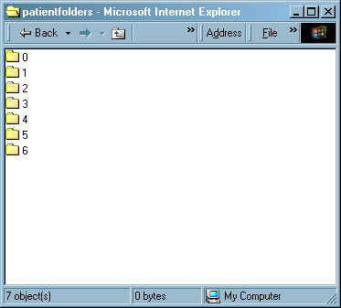
This algorithm (e.g. first 1000 patients in folder “0”, etc.) is for illustration and can be customized; the only requirement is that the algorithm be based on the patient ID.
What is your algorithm? How are the patient folders grouped?

TECHNICAL NOTE: There are two primary reasons hashed folder structures are recommended when a large number of folders may be involved:
Performance: A large number of files in a single folder can cause the operating system to perform a linear scan through the entire folder structure to locate a single file
Scalability: Handling an extremely large folder can be cumbersome (for backups and other administrative activities); a restore would require the restoration of the entire folder
- Drilling down into a patient folder reveals the individual patient subfolders:
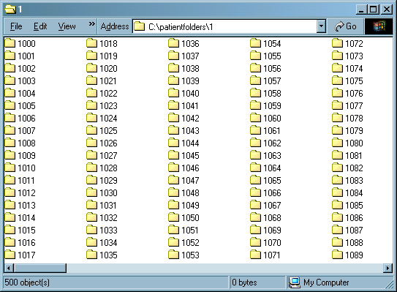
- Optionally, the local system administrator may also choose to create subfolders in each of these patient folders to further organize documents.
- Once this set-up is done, the user can log into athenaNet and find patients with a link on their Quickview screen: “medical files for patient #2400”. Accessing this link opens the pre-created folder for that patient in a new window (a new Windows Explorer or Internet Explorer window, depending on the method of access). As noted, this link could alternatively access a single file, instead of a folder.

Additional Comments
Through completion of this document, if there are general interface comments, not already covered by the questions and sections below, please enter them here:

Limitations
From the interface standpoint, the link(s) presented on the Quickview are static, and is simply a link to a folder or file. The fact that the folder resides on your server, and not an athenahealth server, has several important ramifications:
- The files will only be available if you are on your local network. Users not at your same location will not be able to view these files (if you have multiple offices, it may be possible for your network staff to extend support to the additional offices), and you may not be able view these files if you are logged in from home.
- The files will not be backed up by athenahealth, and athenahealth cannot be held responsible if your server is down. Your system administrator is responsible for this file system.
- Your system administrator is responsible for pre-creating/managing your patient’s folders. If, for example, you click a link and the patient’s folder does not appear, you should not call athenahealth; you should call your system administrator.
- Athena cannot do custom programming to extend this functionality.
- This offering does not support Single Sign-On (SSO) functionality – once the file link is clicked, the user will still need to login to the remote system. If you are looking for SSO functionality, please discuss with your Account Manager or integration program manager. They will need to create a request for an Outbound Single Sign-On integration which would be handled as a separate project. Athena can support SAML2.0.

Go-Live Authorization Form

Continuing Service and Support
Within two weeks after go-live your interface will be transitioned into our daily service and support structure.
As a standard practice, athenahealth continuously monitors all client connections and will notify the contacts specified if an error occurs. All jobs are monitored and automatically restarted if idle.
To contact athenahealth for help or support post go-live, the following resources are available:

¹ Integration Monitoring: IntegrationMonitoringRequests@athenahealth.com
²Interface Network Management: InterfaceNetworkManagement@athenahealth.com
Additionally, it is required to provide support contact information for the client and trading partner for use by athenahealth interface support. When possible, general support hotlines and email address are preferred.
Name | Company | Title | Office Phone | Mobile Phone | Email

Interface Go-Live Signoff
Reference is made to the Athenahealth services agreement (the “Agreement”) entered into by and between athenahealth, Inc. (“Athena”) and the client set forth on the signature page below (“Client”, “you” or “your”). In order to move your interface (or interface change requiring testing) (the “Interface”) into your athenaNet production environment, you must sign off on the functionality of the Interface by execution of this Go Live Authorization Form. Client agrees to fully cooperate with Athena and provide all assistance reasonably necessary for Athena to create, implement and maintain the Interfaces. Client acknowledges that Athena’s performance is contingent on Client’s timely and effective performance of its obligations and understands that the operability of the Interfaces depends on Client’s ability to maintain its own equipment and functionality. Client has obtained or will obtain all consents, licenses, and waivers and has fulfilled all legal obligations that are necessary to allow Athena to create, implement and maintain the Interfaces. It should be understood that additional changes to the scope of the Interface once loaded into athenaNet production will involve additional project work and potentially incur additional costs.
Upon receipt of this signed form, Athena requires a minimum of 2 business days to move your Interface to go live.
The terms of this Go Live Authorization Form are hereby incorporated into the Agreement and shall become effective upon Client’s signature below. By signing below, Client acknowledges that it is satisfied with the functionality of the Interface set forth below and Client authorizes Athena to enable such Interface to be deployed to athenaNet production.

By: _________________________________________
Print Name:
Position:
Date:

