Fusion5
  - Integration Package
athenahealth, Inc.
Version 1.Published February 2019

Project Information
Please fill the following to the best of your ability. While not all contacts are required, you should be able to submit at least two contacts at the onset of a new interface project.
General Information
athenahealth Interface Project Manager Name
athenahealth Interface Project Manager Contact Information
Event Number (provided by Interface Project Manager, for internal athenahealth tracking)

Contact | Role | Details
Project Business Contact | Responsible for overall success of the project | Name:
 |  | Phone:
 |  | Email:
Project Interface Contact | Interface expert, responsible for continuing interface support | Name:
 |  | Phone:
 |  | Email:
Project IT Contact | Networking and security expert, responsible for overall connectivity | Name:
 |  | Phone:
 |  | Email:
Vendor Contact #1 | Role: | Name:
 |  | Phone:
 |  | Email:
Vendor Contact #2 | Role: | Name:
 |  | Phone:
 |  | Email:

Product Description
By choosing to move forward with this standard integration you are committing to the scope outlined below. If you require any customization to this integration, please contact your athenahealth project manager to engage athenahealth’s Integration Design team for detailed scoping. Please note that any customizations will result in this integration becoming a custom interface, and will incur additional fees.

Technical Overview

Third Party System | Fusion5
Interface Type | Outbound Patients
Schematic | 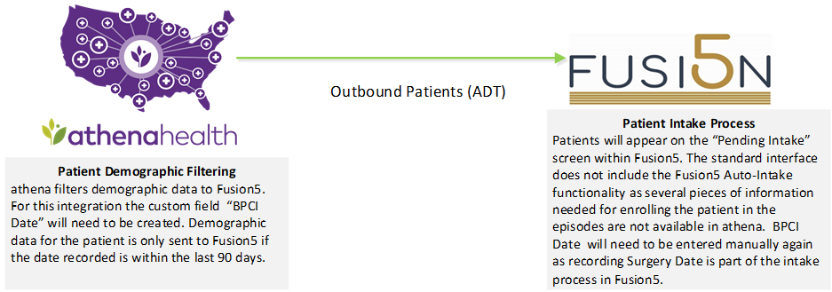
Format | HL7
Data Transfer Direction | Outbound from athenaNet to Fusion5
Frequency of Data Transfer | Real Time
HL7 Message Type(s) | Outbound (from athenaNet): AddPatient (A28), UpdatePatient (A31)
Connectivity | VPN, API
Restrictions | Requires athenaCollector

Scope Approval
I, , agree to the interface design as described here in this document.
Position:
Date:

Go-Live Authorization Form

Continuing Service and Support
Within two weeks after go-live your interface will be transitioned into our daily service and support structure.
As a standard practice, athenahealth continuously monitors all client connections and will notify the contacts specified if an error occurs. All jobs are monitored and automatically restarted if idle.
To contact athenahealth for help or support post go-live, the following resources are available:

¹ Integration Monitoring: IntegrationMonitoringRequests@athenahealth.com
Additionally, it is required to provide support contact information for the client and trading partner for use by athenahealth interface support. When possible, general support hotlines and email address are preferred.
Name | Company | Title | Office Phone | Mobile Phone | Email

Interface Go-Live Signoff
Reference is made to the Athenahealth services agreement (the “Agreement”) entered into by and between athenahealth, Inc. (“Athena”) and the client set forth on the signature page below (“Client”, “you” or “your”). In order to move your interface (or interface change requiring testing) (the “Interface”) into your athenaNet production environment, you must sign off on the functionality of the Interface by execution of this Go Live Authorization Form. Client agrees to fully cooperate with Athena and provide all assistance reasonably necessary for Athena to create, implement and maintain the Interfaces. Client acknowledges that Athena’s performance is contingent on Client’s timely and effective performance of its obligations and understands that the operability of the Interfaces depends on Client’s ability to maintain its own equipment and functionality. Client has obtained or will obtain all consents, licenses, and waivers and has fulfilled all legal obligations that are necessary to allow Athena to create, implement and maintain the Interfaces. It should be understood that additional changes to the scope of the Interface once loaded into athenaNet production will involve additional project work and potentially incur additional costs. In addition, Client acknowledges that moving the Interface to athenaNet production environment may require changes to athenaNet practice settings and in connection with this Go-Live Authorization Form authorizes all required changes in athenaNet.
Upon receipt of this signed form, Athena requires a minimum of 2 business days to move your Interface to go live.
The terms of this Go Live Authorization Form are hereby incorporated into the Agreement and shall become effective upon Client’s signature below. By signing below, Client acknowledges that it is satisfied with the functionality of the Interface set forth below and Client authorizes Athena to enable such Interface to be deployed to athenaNet production.

CLIENT:
By: _________________________________________
Print Name:
Position:
Date:

Appendices and Other References

Planned Maintenance Window
The athenaNet MX Engine is subject to the same maintenance windows as the default, all interfaces are shut-off during this time window, and also remain disabled until 4 A.M. Eastern Time.

Interface Message Queue Manager
The athenaNet Interface Message Queue Manager (IMQM) is an interactive repository for all interface messages that pass through athenaNet. Messages can be categorized into several processing states. Please note that messages in a final state (processed or deleted) will only remain in the queue for 90 days.
Message State | Explanation
SCHEDULED | Scheduled to be sent at a later time
NEW | Placeholder for a new message and ready to be sent or received
DISTRIBUTED | Delivery or acknowledgement is pending for Global interfaces
PENDING | Delivery or acknowledgement is pending
PROCESSED | Processed normally; remains in queue for only 90 days
ERROR | Generic error encountered; routed to client
CBOERROR | Billing related error encountered; routed to client
ATHENAERROR | Internal error encountered; routed to athenahealth Client Support Center
DELETED | Messages that have been deleted; remains in queue for only 90 days
In order to access the IMQM in athenaNet to manually resolve common errors, such as missing providers, invalid procedure codes, or unknown departments, the following user permissions must be granted by the local system administrator:
Permission | Use Case
Interface Admin: View Message Queue | You want to be able to view the IMQM.
Interface Admin: Map Insurance Messages | You need to map insurance messages.
Interface Admin: Map Messages (except Insurances) | You need to map all messages excluding insurance messages (e.g. provider and department mappings).
Interface Admin: File Upload Interface | You want to be able to upload files via the interface.
See athenaNet Interface Queue Management Guide for more information on the functionality of the IMQM and on client-side cleanup for ERRORs and CBOERRORs.

Continuing Service and Support
Within two weeks after go-live your interface will be transitioned into our daily service and support structure.
As a standard practice, athenahealth continuously monitors all client connections and will notify the contacts specified if an error occurs. All jobs are monitored and automatically restarted if idle. For more details please refer to the Interface Down Support Document.
To contact athenahealth for questions or modifications to the interface, support can be accessed directly in athenaNet:

