athenaClinicals
Results Interface Guide

Congratulations! A results-only interface between your local facility and athenahealth is now live in your athenaNet. Our electronic interfaces can significantly decrease fax volume, helping you to meet MU requirements, shorten the amount of time it takes to get results to your practice, and provide you with structured data that can be used by tools in athenaNet. This document shares information about the core functionality of your interface(s).

Contents

Transitioning from paper to electronic interface 2
Patient matching and mapping 3
Incorrect patient mapping 4
Result routing 4
Tying results to the correct order 4
Bolded orders (Labs only) 5
Timing of result generation 5
Order form 5
Production Maintenance and support 6

Transitioning from paper to electronic interface

Over the course of each interface implementation, athenahealth spends a significant amount of time working with the sending facility to meet its testing requirements. Therefore, your electronic results should reflect what you would have typically received via fax. On the first day that your interface is live, you might continue to receive faxed results as you have in the past. You should follow up with the sending facility to make sure that they have turned off your faxed results. Your workflow to review and take actions on the result should not change while transitioning from paper to interface.

Unlike the faxed copies of results, athenaNet creates a separate document for each test performed.

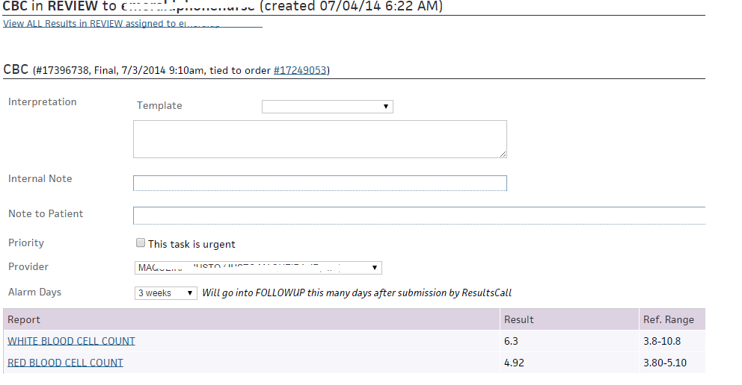

Click the View ALL Results in REVIEW assigned to link to see a consolidated view of all results in REVIEW for the patient.

The consolidated document page displays:

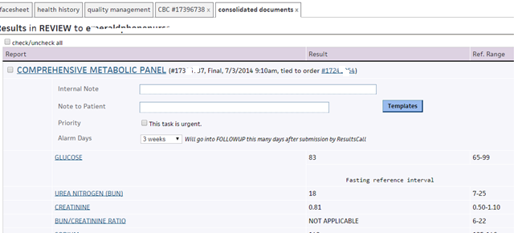

Patient matching and mapping

When athenaNet receives a result, athenaClinicals automatically routes it to the correct patient based on the patient’s first name, last name, middle initial (if provided) and date of birth. If athenaClinicals cannot find an exact match between the patient information in athenaNet and the information sent from the sending facility, it places the result in HOLD status.

You might not see an automatic match for the following reasons:

- The patient goes by two names (e.g., "Bob Smith" is listed in athenaNet, but the performing facility sent "Robert Smith").
- The patient's name is misspelled (e.g., "Kathryn Smith" vs. "Katherine Smith").
- Sending facility sends us a patient’s middle initial, but we don’t have middle initial listed in the patient’s quick view.

In these cases, you can tie the result to the correct patient. When a practice user ties the result to the correct patient, athenaNet creates a mapping that automatically routes any future results from the sending facility, with the same demographics, to the selected patient.

It is important that you check the patient’s athenahealth ID# and date of birth when tying a result to a patient. You must map the results to the correct patient.

In order to tie result to the patient, please follow the steps below:
Look at the result to determine what patient demographics the lab/imaging center sent to athena. You will see it in red on the top of the result.

Find that patient in athena to confirm the name as appears in athena to assure result belongs to that patient
Start typing the patient name or athena patient id in the Patient Name/ID box:

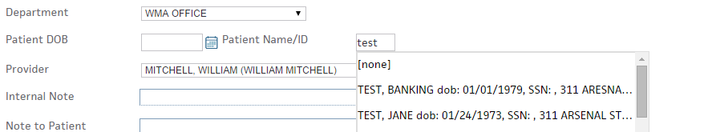

Select the right patient from the drop down.
Scroll all of way down and on the right corner you will see the save button; click it to save your changes.

Incorrect patient mapping
If a result is tied to a wrong patient, please call AthenaCSC

Result routing

When athenaNet receives an interface result, it routes the result to your practice based on information provided by the performing facility. Most national labs provide athenaNet with a unique identifier in the message to help us route results to the correct department. If the facility is unable to provide us with a department identifier, athenaNet routes your results based on your provider(s) primary department (provided by the client to athena).

If athenaNet receives results for your practice for unlisted providers, we map the result documents to your STAFF inbox. If you have providers that work out of multiple departments, you must let athenahealth know which department that provider uses as a primary location. If you believe that one of these mappings is incorrect, please contact the CSC to have it modified.

Please note that athenaNet can route a result for an account number or provider to only one department.

Tying results to the correct order

When athenaNet receives results via your interface, it attempts to automatically map them to an order that you placed in athenaClinicals. If athenaNet can find a matching order (in the submitted or closed status) for the correct patient in your practice, it ties the results to that order. If the result returned by the performing facility does not match the original order, athenaNet cannot automatically tie results to the order.

For example, if a provider ordered a URINALYSIS COMPLETE but received results for a URINE CULTURE those results would not be tied to the order. You can still manually tie the results to the order if you believe the lab performed the correct test.

If you are concerned that a result order type that you received for a particular order is incorrect, please check that you ordered the right test. See the section about order bolding (below) for more information. If you ordered a bolded test, and you still believe that the test results are different than what you ordered, please contact the CSC.

Bolded orders (Labs only)

athenaClinicals bolds lab order types to show providers that the lab offers a particular test. Selecting a bolded test greatly increases the likelihood that athenaNet can automatically tie a lab result to the corresponding order. We encourage providers to select a bolded test when placing a lab order, if one is available. To support order bolding, select your lab's clinical provider as a preferred lab in the patient’s quickview and/or select the lab's clinical provider when creating an order quickpick.

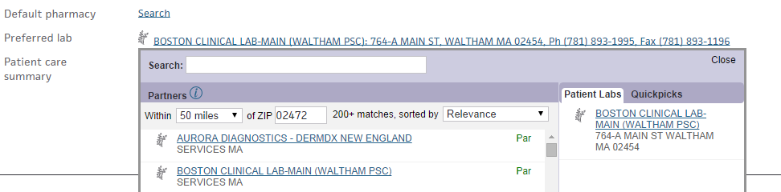

Timing of result generation

Interface results are generated in real-time and appear in the patient's chart as soon as the sending facility sends them.

Order form

Occasionally a performing facility requires the provider to include their lab account number on the lab order form. Please contact the CSC to request that they include the account number on the form.

Production Maintenance and support

The athenaClinicals support team monitors all interfaces seven days a week, from 6:00 a.m. to 8:00 p.m. ET, for traffic and errors. If you are expecting a result but have not received it, please contact the sending facility first. If you have already spoken with their representative, and they verified that they sent the result, please contact the CSC.

Additionally, if you believe there is an issue with an interface result, you can put the document to athenaerror with the action note and athena support team will help you to solve an issue. To place a result to athenaerror status, please follow the steps below:

- When you open a result, click on view actions link:
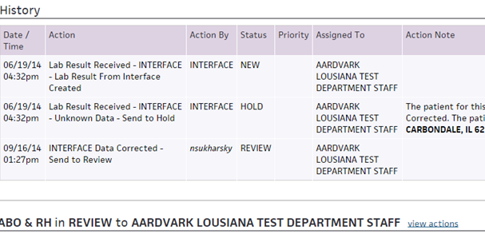

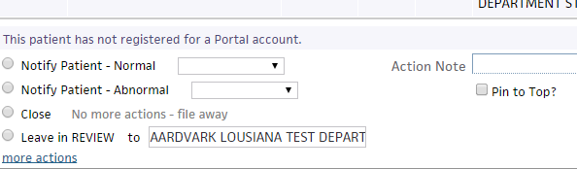

- Click more actions link
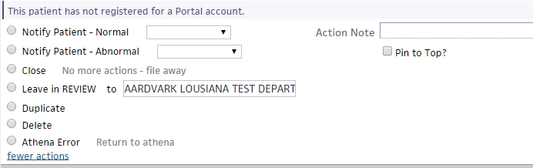

- Select athenaerror and add a note describing the interface issue and click save. The athenahealth support team will investigate the document for you. Please note that not all issues can be resolved via the athenaerror status. Our support team might request that you contact the CSC.

For any other questions/trainings we recommend to use athenaNet O-Help. To access O-Help, please go to Support, choose O-Help and type key words for your question. If you cannot find an answer, please contact the athenaCSC.

