athenaLightning: Folder Based
  - Interface Connectivity Solution – User Guide
athenahealth, Inc.
Version 17.4 Published: April 2017

athenaClinicals® Service

Q3 2013 Edition
athenahealth, Inc.
Published: July 2013

Table of Contents
Table of Contents 2
Overview 3
How It Works 4
Installation 5
System Requirements 5
Installation Setup 5
Managing your Interfaces 8
Changing the Data Storage Location 8
Adding an Interface 9
Testing an Interface 11
Editing an Interface 11
Deleting an Interface 12
Disabling the Lightning Service 12
Recovering an Interface 14
Troubleshooting 15
Uninstalling Lightning 16

Overview
Lightning is a secure lightweight connectivity solution created by athenahealth that is able to transfer messages both to and from athenaNet. As Lightning is preconfigured to securely access athenahealth’s network, interfaces are much faster to set up for both senders and receivers.
Lightning downloads/uploads messages from/to athenaNet via secure web service transactions (HTTPS port: 443) to/from a client’s local machine. A separate encrypted passcode is stored locally and regenerated periodically to ensure the security of the data being sent. This solution also provides a simple user interface to manage your interfaces with athenahealth, along with options to archive messages and change the location of where your data is stored.
The Lightning Folder connection is a file-based connection where athenaNet is writing messages to the folder specified, and in that way mimics an SFTP connection but is without the need for an FTP job to be scheduled. If there are messages to grab, the Lightning application will pull the messages within seconds. If there are not messages, it will sleep for 20 seconds before attempting again to grab any messages.

Note: Lightning is not compatible with 835 and 837 ANSI files.

How It Works
After installing Lightning and configuring an interface, Lightning will create a folder in the Data Storage Location you have specified (default: /Program Files/athenahealth/Lightning/LightningDataFolders). The name of the folder will be the same name as your interface. In the interface folder, you will find folders specifying the direction of the interface:
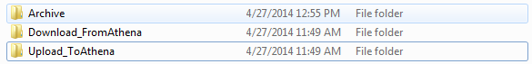
If you have created an Upload To Athena Interface, you can push messages to the Upload To Athena folder and Lightning will pick them up and send them to athenaNet.
Note: The messages that are picked up and delivered are automatically deleted from the interface folder. If you configure the interface to archive sent files an Archive folder will be created in your interface folder.
If you have created a Download From Athena Interface, you can pull messages sent from athenaNet from the Download From Athena folder.

Installation

System Requirements
- Supported on:
  - Windows 7
  - Windows XP
  - Windows Server 2008
  - Windows Server 2003
- Requires a 64-bit minimum Windows System to run
- Internet connection
- Admin permissions

Installation Setup
- Download the Lightning installation package using the link that your athenahealth interface project manager provided.
- Place the installation’s zip file (Lightning_Setup.zip) on the computer that will run the service.
- Open the zip file and extract the contents to a specific destination. Please make note of the destination.
- Open the Lightning Setup folder.

- Right-click the installer file (Setup) and select Run as administrator. This can be run as either the .bat file or the .exe file.
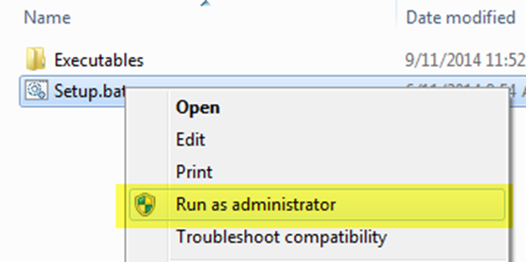

- Click Next then read the License Agreement. If you agree to the terms, click the ‘I accept the terms in the license agreement’ radio button and click Next.

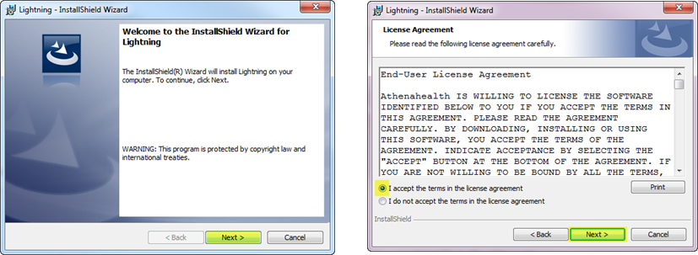

- The installation location is defaulted for you, if you wish to change the install location click the Change… button and select the folder you wish Lightning to be installed in. Once you have selected a folder you can click Next.

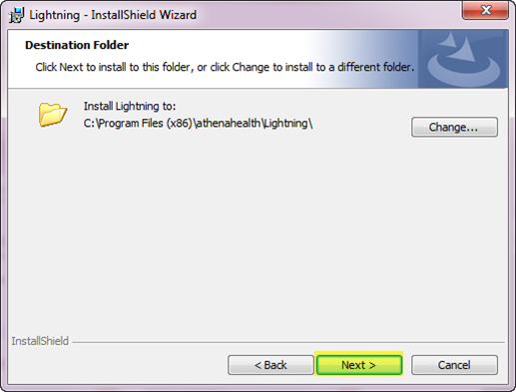

- Click the Install button.
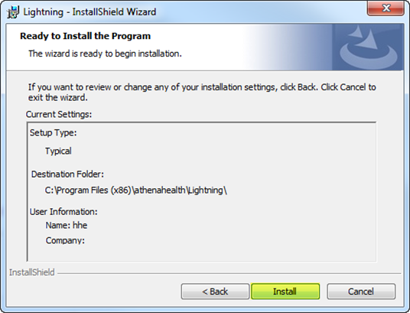
- At the completion screen, click the Finish button.

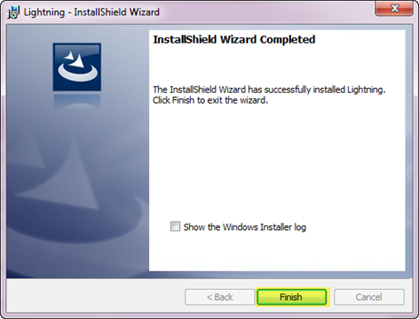

- You will be prompted to select the location you wish Lightning to upload/download data from when Lightning runs for the first time. If you wish to change the location from the default press Browse and select a location on your machine. You can then press Save when finished.

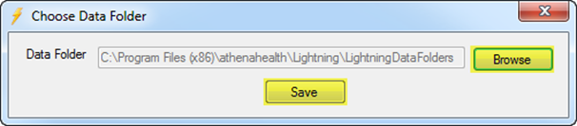

- The updater will run and the Lightning icon will appear in the Windows tray once the installation is complete.

Managing your Interfaces
Navigation: You can manage all of your interfaces right from the Lightning application window. If the Lightning application is not open, simply open the application from the location where it was originally installed.
If it is already running, open your system tray and right click the Lightning icon. From the menu select the Show Window option.
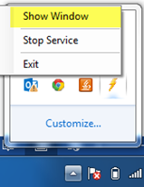
From the Lightning application window you are able to change the location where data is pushed/pulled on your machine as well as add, edit, test, and delete all the interfaces you have with athenahealth.

Changing the Data Storage Location
- Navigate to the Edit option on the top of the window and select Data Storage Location. Please note, it is not recommended to change this after you have set up interface connections.

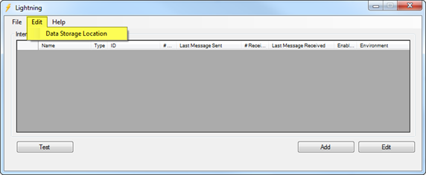

- From here Lightning will prompt you to select a new data folder to upload/download files from. If you wish to change the folder from the default, click the Browse button and select the desired folder from your file directory, then click the Save button. If you wish to use the default, just close the window.

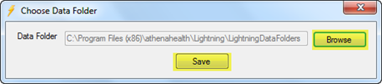

Adding an Interface
Note: If the connections are not downloaded and set-up correctly, they will have to be deleted and the interface connection will have to be re-created.
- Navigate to the Lightning application window. Click the Add button.

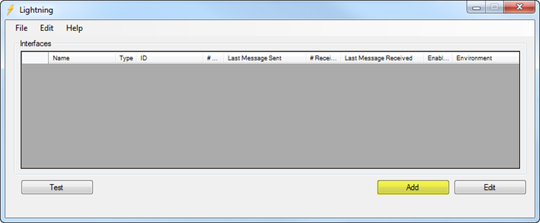

- A pop-up will appear with many different options to apply to your interface. These options are detailed below:
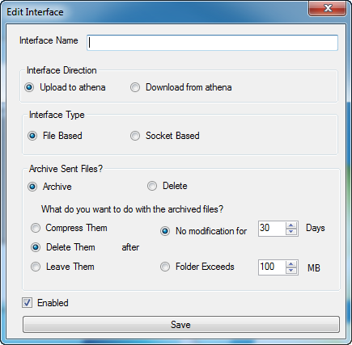

  - Interface Name
    - Considerations
      - This is the name of the interface that will appear on the Lightning application window and on the folder in the Data Storage Location previously configured.
      - It is recommended to create one connection per message type. For example, if the project involves an outbound demographics feed, an outbound orders feed, an inbound results feed, and an inbound charges feed, a total of 4 connections would be needed. Please speak with your athenahealth interface project manager if this requires clarification.
    - Instructions
      - We recommend the following naming convention: the “Practice name” or Context ID (provided by your athenahealth interface project manager) and “vendor” name that are specific to your project.
        - Download from athena – for the outbound from athena connection
          - Practicename_athena_to_vendor_Test
          - Practicename_athena_to_vendor_Prod
        - Upload to athena – for the inbound to athena connection
          - Practicename_vendor_to_athena_Test
          - Practicename_vendor_to_athena_Prod.
  - Interface Direction

Upload To Athena (Up) | Interface that sends messages to athenahealth.
Download From Athena(Down) | Interface that receives messages from athenahealth

  - Interface Type

File Based | Upload: Physical files are being written to the Upload_ToAthena Folder  Download: Physical files are written to the Download_FromAthena Folder

  - Archive Sent Files: When messages are sent to athenahealth, the files are automatically deleted from the data folder that your machine is pushing to. When configuring an interface you are able to select the Archive option to have the files that were sent saved to an Archive folder. You can then configure the archiving behavior with the various options described below:

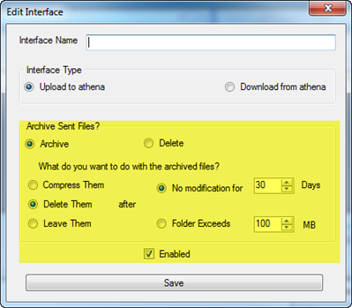
Compress Them | Files saved to the archive folder will be compressed based on the parameters set on the right (after X number of days/when the folder size exceeds X mb)
Delete Them | Files saved to the archive folder will be deleted based on the parameters set on the right (after X number of days/when the folder size exceeds X mb)
Leave Them | Files saved to the archive folder will remain in the folder in their original state.

Note: Selecting the Delete option will delete any existing Archives. It is recommended that you back up your Archive folder to a different location before selecting this option if there is data you wish to save.

  - Enabled: When this box is checked the interface is actively sending/receiving messages. If this box is unchecked, the interface will be disabled until it is re-enabled by the user. When an Upload To Athena connection is re-enabled, messages queued in the folder will resume sending. When a Download From Athena connection is re-enabled, messages queued will be sent from the time the interface was disabled.
    - Check the enabled box to ensure that your interfaces are active.
- Click Save once you have finished configuring the interface.
Note: This will create a folder in the previously configured Data storage location with the same name as the interface.
- Now that you have finished configuring the interface on your machine, the interface can be connected to athenaNet. Please contact the athenahealth interface project manager you have been working with for setup. You will be asked for the first few digits of the interface ID located below, also referred to as the “GUID.” This can be sent in an encrypted email or over the phone.

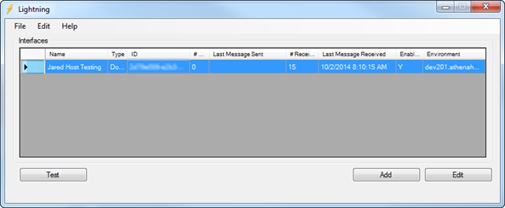

Testing an Interface
In the Lightning tray app, you have the ability to test your interface. This test checks whether you are able to connect to athenaNet.
- Navigate to the Lightning application window. Click the interface you wish to test and click the Test button.
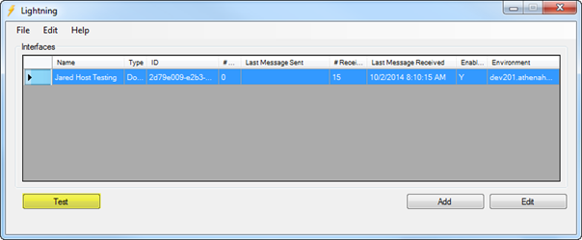
- If there is an issue, make sure that Lightning has access to write to the data folders you specified on setup. If it still is not working please contact the athenahealth interface project manager.

Editing an Interface
The options for editing an interface are as follows:
- Interface name
- Archiving preference
To edit an interface, navigate to the Lightning application window. Click the interface you wish to edit and click the Edit button.
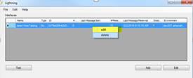

Please update your athenahealth interface project manager with any changes made.
Note: It is strongly recommended not to make any additional edits as it could disable an existing live or test interface.

Deleting an Interface
- Navigate to the Lightning application window. Click the interface you wish to delete and click the Delete button.
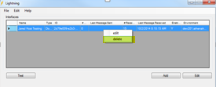

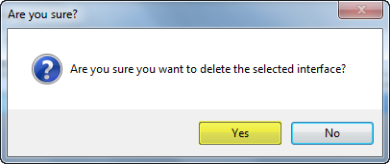
- A pop-up will appear and ask you to confirm your intent to delete your interface. If you wish to delete the interface click Yes.

Note: A deleted interface can only be recovered by contacting your athenahealth interface project manager. If you accidentally delete your interface, or wish to create a new interface you must contact athenahealth to ensure that messages will be sent/received.

Disabling the Lightning Service
Disabling the Lightning service will stop all messages from all interfaces from being downloaded/uploaded to and from athenaNet. When re-enabled, queued messages from athenaNet will be downloaded to the Download_FromAthena data folders and files in the Upload_ToAthena data folders will be uploaded to athenaNet.
- Navigate to the Windows tray and right-click the Lightning icon.

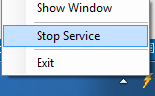

- Select the Stop Service option. You should see the icon change to reflect the status of the service.

Recovering an Interface
If you need to recover an interface or multiple interfaces you can use the Recover Interfaces functionality.
Possible reasons for needing to recover an interface:
- You accidentally deleted an interface in the Lightning application
- The computer/server that was running Lightning crashes
- You are swapping the computer/server you run Lightning on
- You accidentally uninstalled Lightning
Follow the steps below to submit a recovery request:
- Click Help on the left corner of the Lightning application and select Recover Interfaces
- Send an email to your athenahealth interface project manager if you are still in pre-go live stage. If not, call the CSC and include the following information:
  - Context ID
  - Names of interfaces
  - Types of interfaces
  - Name of business or intermediary
  - Contact information
  - Issue description
- athenahealth will contact you and walk you through the recovery process.

Troubleshooting
If your interface is not installing/sending or receiving messages properly, there are a few steps you can take to help identify any issues.
Please note: athenahealth cannot troubleshoot issues between the Lightning application and your vendor system, as we are only connecting with the Lightning application. Therefore, it may be necessary to engage your vendor’s support team for complex issues.
Lightning’s log files can provide the athenahealth support team information about the issue that is occurring. Below are instructions on how to download these files:
- Click File on the top left corner of the Lightning application and select Export Logs
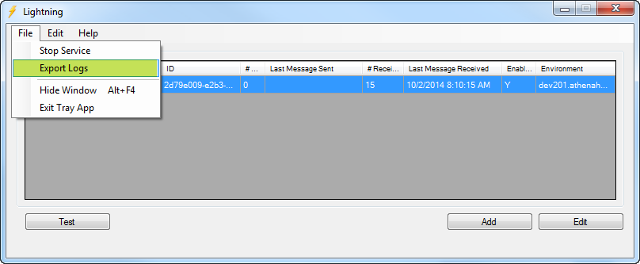

- Select the location you would like to save the .zip file containing the Lightning logs.
- Email your athenahealth interface project manager for pre-live interfaces or call the CSC for live interfaces with a description of the issue you are seeing and the zipped logfile attached.

Uninstalling Lightning
- Navigate to: Start > All Programs > athenahealth > Lightning
- Click Uninstall Lightning
